**Lab 7: Common-Source N-Channel MOSFET Voltage Amplifier**

EE 3310L

Spring 2023

Alex Yeoh

Cauy Gibson

Submitted to TA: C. Hicks Saturday 11:07 PM

Date of Experiment: 02/24/23

Date of Submission 03/11/23

1. **Introduction**

The purpose of this lab is to construct and test a common-source voltage amplifier using a 2N7000 N-channel enhancement-type MOSFET [1]. A common-source N-nhannel MOSFET voltage amplifier is a essentially a common-emitter NPN amplifier with the BJT replaced with a N-channel enhancement-type MOSFET. The different transistor is important because the N-channel enhancement-type MOSFET does not have any gate voltage which removes any concern about ß and allows for much larger input resistances. The DC values of the circuit can be measured separately from any portion with a capacitor between them the transistor due to capacitors acting like open circuits with DC.

1. **Experimental Methodology [1]**

The first step of the experiment is constructing the circuit following figure 1 below.

Figure 1: Common-emitter NPN voltage amplifier

From the circuit, voltage at the gate, source and drain are measured. The voltage at the source terminal of the transistor should be approximately 1.8V.

The signal generator is then set to a 1Vp-p and 1kHZ sine wave. The peak-to-peak output voltage is then measured. The frequency is then increased until the output has decreased by 3dB, the resulting frequency is written down as the upper cutoff frequency. The frequency is then decreased until the output has also decreased by 3dB, the resulting frequency is written down as the lower cutoff frequency. The signal generator is then brought back to a frequency of 1kHz, and the peak-to-peak voltage is then increased until the output waveform is visibly clipping.

1. **Results and Description**

The measured voltages at the gate, source and drain in the circuit in figure 1 above, when the signal generator is off, are 3.12V, 1.91V and 11.13V respectively.

The wave generated from the circuit in figure 1 above did appear to look like an inverted sine wave.

The circuit in figure 1 above had a measured peak-to-peak output voltage of 324mVP-P. From this value, the calculated gain from the circuit seen in figure 1 can be seen in equation 1 below.

$A_{V}=\frac{V_{OUT}}{V_{S}}=\frac{3.324}{(1/100)}=32.4=30.21dB inverting$ (1)

The measured upper and lower cutoff frequencies for the circuit seen in figure 1 above are 420kHz and 5.4Hz respectively.

The peak-to-peak voltage at which the circuit seen in figure 2 above’s waveform appears clipped is 11.9Vp-p.

1. **Discussion**

The analytically determined DC operating point, gain, and both upper and lower cutoff frequencies can be seen below in figure A1 in appendix a.

The Multisim simulated DC operating point for a common-emitter NPN voltage amplifier can be seen below in figure 2.

Figure 2: Simulated DC operating point from Multisim for a Common-emitter NPN voltage amplifier

The Multisim simulated gain and both upper and lower cutoff frequencies for a common-emitter NPN voltage amplifier can be seen below in figure 3.

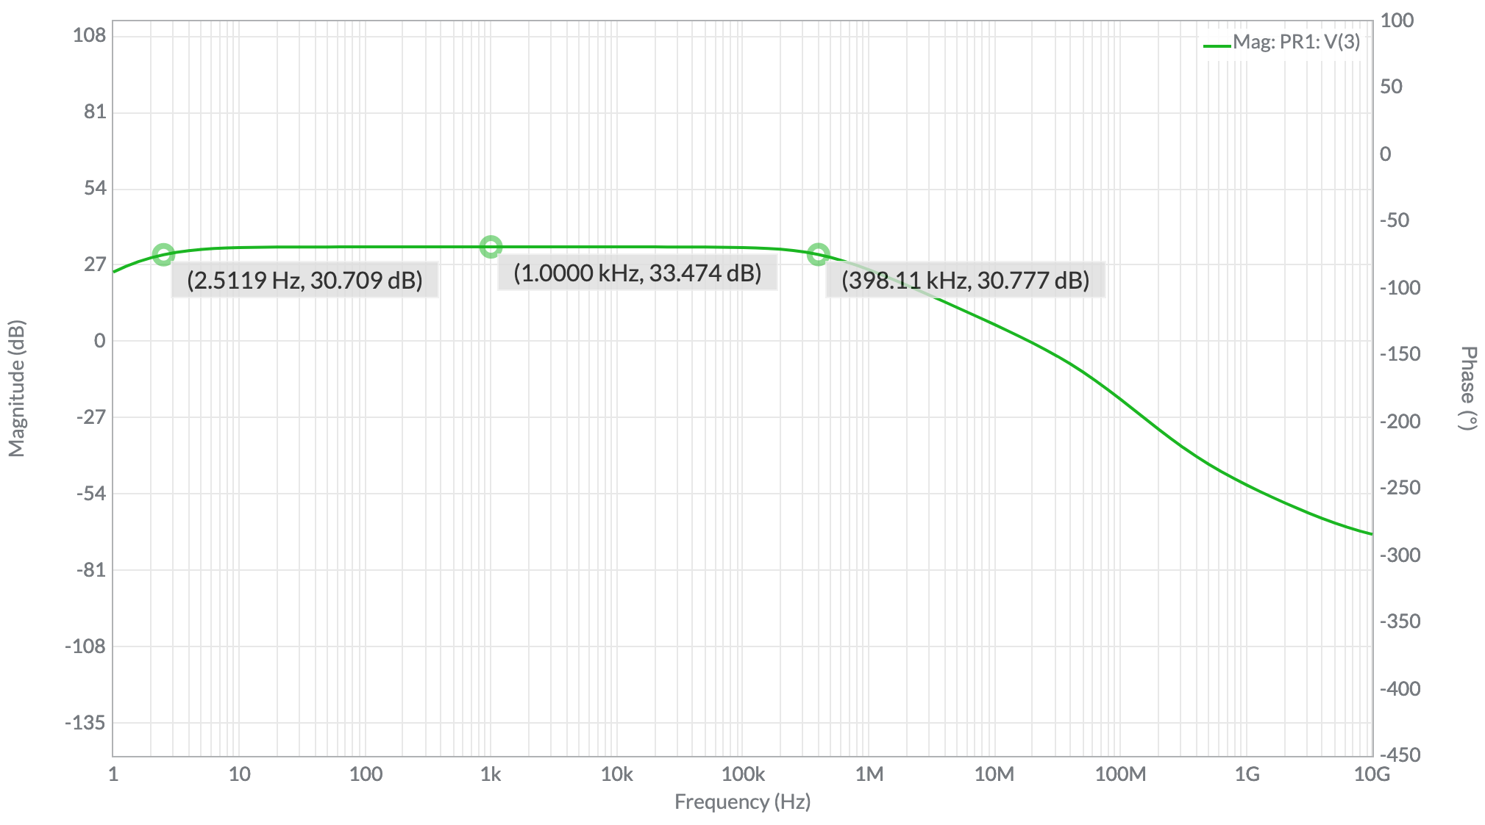

Figure 3: Simulated gain from Multisim for a common-emitter NPN voltage amplifier with upper and lower cutoff frequencies displayed

The calculated and simulated gate voltages were similar while the experimental value was smaller, the calculated and experimental source voltages were similar while the simulated was smaller and, the calculated and experimental drain voltages were closer in value to each other than either were to the simulated value. All three gains were similar. The simulated and calculated low frequency cutoff values were similar while the experimental value was slightly higher. The simulated and experimental high frequency cutoff values were similar while the calculated value was much higher.

1. **Summary and Conclusions**

The most of lab itself is simple and straightforward to complete due to the instructions given.

**Reference**

[1] Tritschler, Joe. "Common-Source N-Channel MOSFET Voltage Amplifier." N.p., n.d. Web. 24 Feb 2023.

**Appendix A**

Analytical Calculations for Lab 7

Figure A1: Full analysis for a common-source n-channel MOSFET voltage amplifier.